

**SWOT ANALYSIS**

**• SWOT analysis to identify your company’s current situation.**

**Strengths - What advantages does your company have? What do you do better than anyone else? What internal resources do you have? Positive attributes of people. Tangible assets of the company**

**Weaknesses - What factors could cause you to not onboard new customers, or to lose customers once they have used your product? What areas should you avoid? What areas need improvement to gain a competitive edge?**

**Opportunities - What potential avenues can take your product down in the future? What possible changes in government, technology or the market could be utilized by your company? What other businesses could your product collaborate with in the future to increase reach?**

**Threats - What are competitors doing that could undermine your success? Can you foresee any changes in government, technology or the market that could hinder your success? Has there, or will there be, a significant change in supplier prices or the availability of raw material?**

|  | Helpful (to achieving the objective) | Harmful (to achieving the objective) |
| --- | --- | --- |
| Internal (attributes of the organization) | **Strengths** | **Weaknesses** |
| -Partially fabricated in Portugal; buy national goods because that’s a way to help national economy. Even then, cannot be 100% Portuguese, as Science4You, for example, due to electronic components/PCB.  -New and innovative concept: building electronic circuits with toys is still very unexplored  -Constant innovation and development: work everyday to develop new toys (and create improvements to current lines perhaps); can achieve large portfolio  -Compatible with Lego (todas as vantagens daí, tal como Licensing Agreements com popular IPs, Adult fans, easier to access global market)  -Concept of building city with our products incentivizes returning customers  -Teaches about Electronics - incredibly useful matter not very commonly taught amongst kids | .-No brand recognition on itself  -High prices - may discourage price-sensitive customers and limit the brand’s ability to attract a broader consumer base.  -Dependence on Plastic: which faces increasing scrutiny due to environmental concerns. Urgent researching on sustainable materials incorporation  -Requires armazenamento de mercadoria, todos os problemas que advém daí |
| External (attributes of the environment) | **Opportunities** | **Threats** |
| -High growth in the educational toy sector  -Emerging Markets: Expanding into emerging markets, such as Asia, Africa, and South America, can help tap into new consumer bases and achieve long-term growth.  -Direct-to-Consumer Sales: Strengthening its e-commerce capabilities and offering exclusive products through its online store can help capture more value from direct-to-consumer sales, reducing dependency on third-party retailers.  -Possibilidade de incorporação em currículos nas escolas  -Environmental Concerns: in case e-waste included  -Strong EU market (although UK included) - According to the Toy Industries of Europe (TIE) association, the European Union was the largest toy market in the world in 2011, meeting the demand of 78 million children under 14 and with a total consumer spending of €16.5 billion, these. 1,8 billion were spent in educational toys.  -Increasing importance of Electronics with digitalization and technology advancements | -Modest growth in most western economies  -Very high seasonality of toys market. The toy market in Europe was extremely seasonal, the majority of purchases occurring during the Christmas period, approximately 60% in November and December.  -Intense Competition: The toy industry is highly competitive, with numerous established brands and new entrants vying for market share. Even faces competition from other construction toy makers and alternative forms of entertainment, such as video games and mobile apps.  -Changing Consumer Preferences: growing popularity of digital entertainment poses a challenge, as children may increasingly favor screen-based activities over traditional toys.  -Environmental Concerns: about plastic pollution and environmental sustainability grow  -Economic Conditions: The toy industry is sensitive to economic fluctuations, as consumer spending on non-essential items tends to decrease during economic downturns. Adverse economic conditions or shifts in consumer preferences may impact business.  -Supply Chain Disruptions: Global events, such as natural disasters, political instability, or pandemics. The company must develop contingency plans and adopt flexible supply chain strategies to mitigate these risks.  -intensification of competition from illegal and fake products  -short life cycle of toys  - the increasing of safety and environmental legislation leading to an increase of testing and administrative costs |



**Tabela de ticks and crosses**

| Company | Educationaltoys | Low price | Digital content | Electronics | Ownshops | Physical retailers | 100% Portuguese | Extendable for teenagers |
| --- | --- | --- | --- | --- | --- | --- | --- | --- |
| Science4You | y | n | n | n | y | y | y | y |
| Concentra | n | y | n | n | n | y | y | n |
| Hasbro | n | y | n | n | n | y | n | n |
| Mattel | n | y | n | n | n | y | n | y |
| KiwiCo | y | y*monthly subscription | n | y | n | n | n | y |
| SAMLabs | y | n | y | y | n | n | n | n |
| Brixo | y | n | n | y | n | n | n | y |
| Elenco Electronics | y | n | n | y | n | y | n | n |
| Lego | n | n*depends | y | n | y | y | n | y |
| H2Ohm | y | n | y | y | n | n | n | y - Legos |



**Questões dos slides**

**• You will always have competitors. Having competitors is a good thing, it is proof that you have a market!**

**Your goal is to figure out a way to penetrate that market and dominate a share of it. The best way to approach this is to identify the three strongest competitors.**

Elenco Electronics, Lego, Science4You

**• For each competitor, identify the following:**

**What are their strengths?**

Elenco - Established brand (created in 1972, 25 million $ in revenue, $241,305 per employee, 105 employees), strong market share in their industry, Revenue generated per employee is greater than industry average, Revenue growth is more steady than the industry average

Lego - Multiple Combinations, Creativity [not really in H2Ohm], global brand, links with movie franchises

Science4You - 100% Portuguese brand, subsidiaries in Spain & UK,the company started its internationalization program one year later through exports.

**What are their weaknesses?**

Elenco - operates mostly in Canada and USA - not a global brand, only accessible to kids (not teens), very expensive (about 100$ each product)

Lego - expensive (The price-conscious customers replace the toys of Lego with some other cheaper brand’s product) - for example, The deals with successful movie franchises cost a lot of money - , Clones of Lego (The fake clones of Lego are disturbing the share value of the company. The brand couldn’t stop the fake clones. Even since the patent and copyrights of Lego expired in 1980, many competitor companies jumped into the interconnected bricks manufacturing industry. They have also started offering the same products and Lego couldn’t file a lawsuit against them.)

Science4You - storage problems, significativos percalços em passado recente (went bankrupt and needed resgate), no digital content, grande sazonalidade, does NOT tackle Electronics, only appeases kids

**Why is your solution better than what they offer?**

Elenco - Lego-based concept is worldwide-successful

Lego - educational toys

Science4You - teaches Electronics

**•Create a graph. A market positioning matrix, a ‘perceptual map’, will allow you to visually represent where your business fits in the market relative to your competitors. This will help you define where your niche exists.**



Educational toys mostly fail to be interesting enough to play. Adding movement/light/sound/etc + Lego concept fixes it. Not as recreative as Lego itself, which main focus is playing.

**• What defines you in relation to your competitors?**

Educational toys focused on Electronics based on a concept (Legos) that is a huge success and universally revered, but at the same time an incredibly innovative idea of manufacturing them.

**• How your customers would describe you to their friends who have never heard about you?**

“It’s just like Legos, but it made my kid interested in learning Electronics!”

“These toys are fucking incredible, holy shit motherfucker!”

“It has many qualities, like being educational, compatible with Legos and smart designs - my kid still uses the Lighthouse as a Night-Light when he goes to sleep! However, we have to keep buying new toys all the time, since there’s not much reason for them to play with the toys once they have been built.”



**Additional stuff**

Both figures in Portuguese market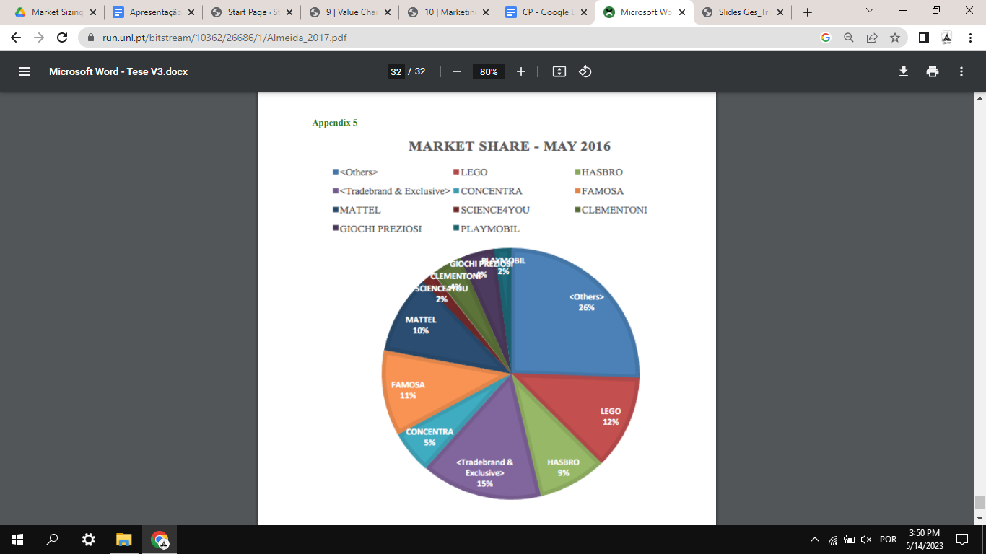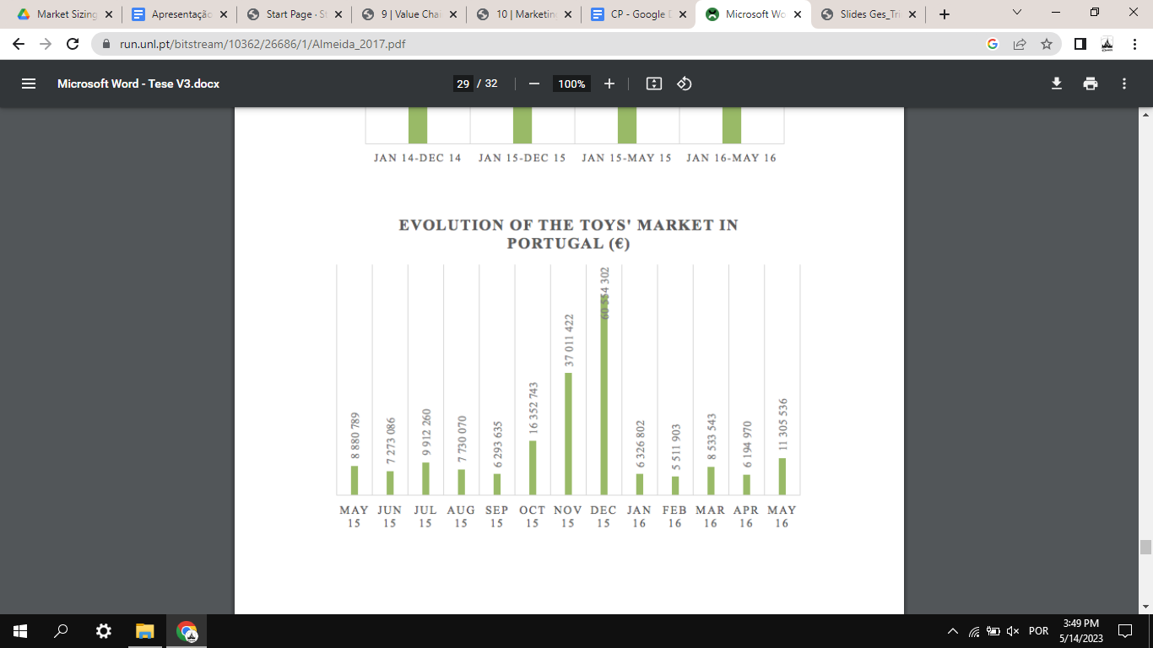

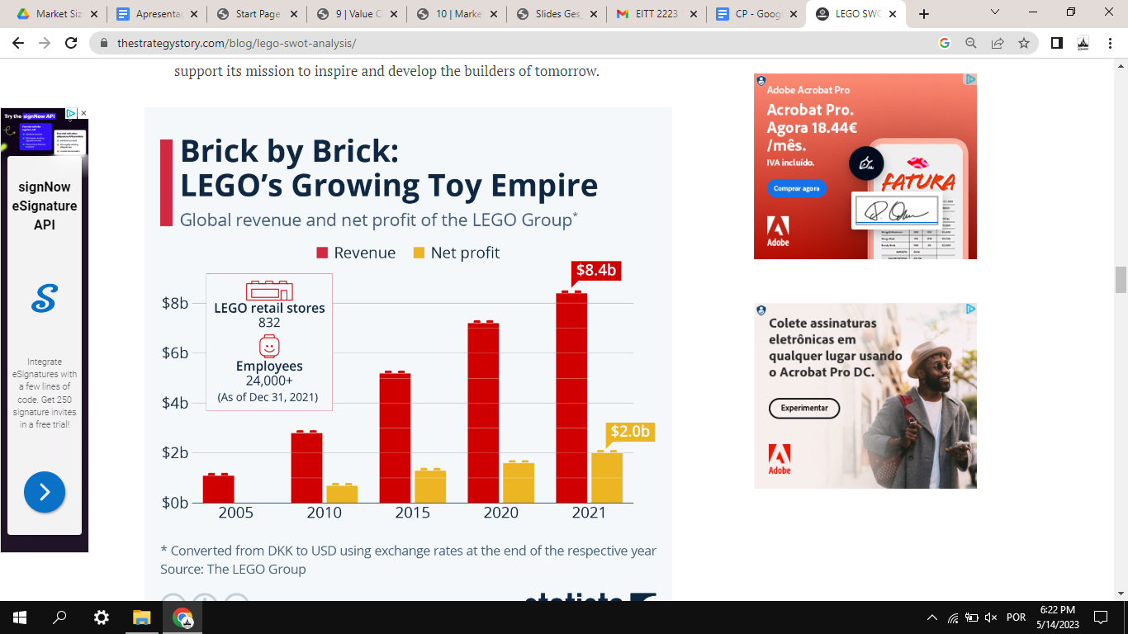

<https://run.unl.pt/bitstream/10362/26686/1/Almeida_2017.pdf>

<https://thestrategystory.com/blog/lego-swot-analysis/>

<https://repositorio.ucp.pt/bitstream/10400.14/20540/1/Master%20Thesis%20-%20Science4you%20in%20the%20UK.pdf>

Onde comprar:

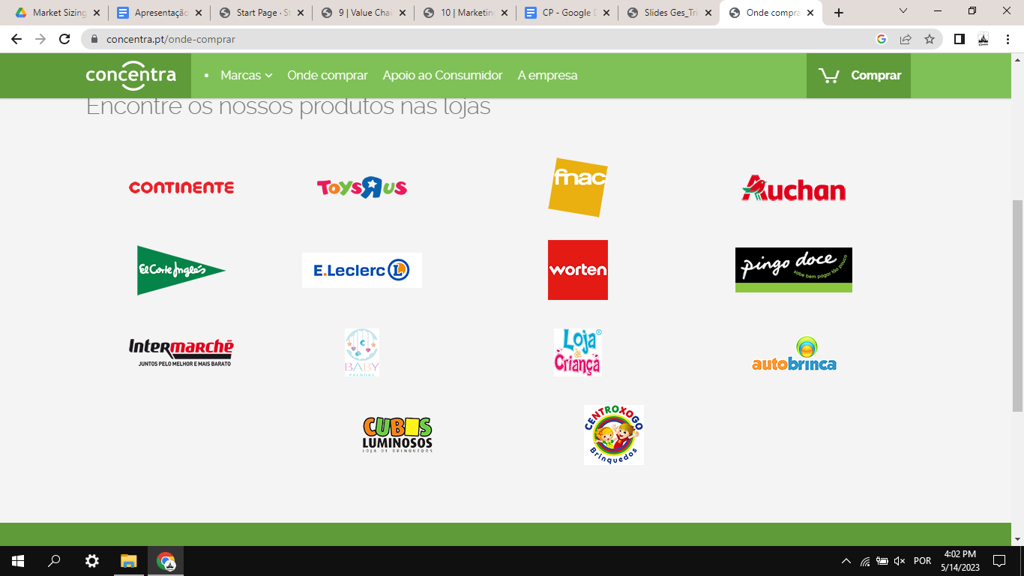

Nota:

**Can I start a business similar to Lego?**

If you want to make a building toy in general, a similar idea to lego, then sure! but you need to think about how. you will be in direct competition with lego, and lego is very hard to compete with

<https://www.quora.com/Is-Lego-patented-Can-other-companies-sell-it>